A Privacy and Verifiability Retaining Framework for Heart Disease Prediction through Various Machine Learning Approaches

Israt Tasnim Esha^{a*}, Dola Dasª, Kazi Md. Rokibul Alamª
ªDepartment of Computer Science and Engineering (CSE),
Khulna University of Engineering & Technology (KUET),
Khulna-9203, Bangladesh.

Email addresses:
israttasnimesha1046@gmail.com (Israt Tasnim Esha)
dola.das@cse.kuet.ac.bd (Dola Das)
rokib@cse.kuet.ac.bd (Kazi Md. Rokibul Alam)

ORCID iDs:
Israt Tasnim Esha: [0009-0008-3936-1803]
Dola Das: [0000-0001-9001-4593]
Kazi Md. Rokibul Alam: [0000-0003-4895-7234]

Acknowledgment:
The authors thank the respective dataset contributors for providing open access to the data used in this research.

*Corresponding author: Israt Tasnim Esha
Email: israttasnimesha1046@gmail.com
Phone: +8801791294697

Abstract
Accountable heart disease (HD) prediction over patients’ sensitive medical data demands preserving privacy, verifiability of data integrity, and authenticity of user queries. However, existing works rarely address privacy comprehensively, and almost none ensure verifiability or authenticity. This paper presents a framework for HD prediction that: (i) categorizes and distributes features among entities to encrypt private medical data; (ii) introduces a two-level verification process to ensure data and prediction integrity; (iii) protects user queries; and (iv) authenticates both queries and their corresponding predictions. Ensemble learning with StackingCV, combining soft and hard voting, was applied to enhance accuracy and robustness. Categorization before encryption achieved 92.05% accuracy, surpassing uncategorized encryption at 87.95%, while feature wise distribution safeguarded data confidentiality. The two-level verification confirmed both data consistency and correctness of prediction execution. User query protection and digital signature-based authentication preserved secure communication and verified legitimacy of both queries and predictions. For post-hoc interpretability, Permutation Feature Importance assessed feature influence, LIME provided visual explanations for individual user predictions, and SHAP offered global and local interpretability by quantifying feature contributions and confirming model consistency. The proposed framework demonstrated that HD prediction on encrypted categorized data maintained less than a 0.5% performance difference compared to plain categorized data. Overall, the system establishes a privacy preserving, verifiable, and interpretable solution for secure and trustworthy machine learning-based healthcare applications.

Keywords Heart disease prediction · Data privacy · ElGamal cryptosystem · Machine learning · Secure interaction

Introduction

Heart disease (HD) remains one of the most pressing global public health concerns, affecting nearly 26 million individuals worldwide [1]. It continues to be the leading cause of mortality, especially as the elderly population grows globally and patients in rural areas often face unavailability of diagnostic tools [2–4]. In response, healthcare systems are increasingly relying on digital health records and remote diagnostic platforms to facilitate early detection and personalized care. Within this evolving landscape, it has become increasingly important to consider predictive reliability alongside concerns related to privacy, data integrity, verifiability of system processes, and authentication of both systems and users. In processing with highly sensitive medical and personal information, unprotected systems risk exposing and making them vulnerable to misuse and breaches. That’s why maintaining trustworthiness of entities within the framework and preserving data privacy are vital concerns. Besides, categorizing data prior to encryption enables efficient secure processing along with high prediction accuracy. Furthermore, trustworthy HD prediction requires not only diagnostic accuracy but also verifiable processing pipelines, because compromised data integrity or inappropriate usage of data in HD prediction can lead to misdiagnosis, inappropriate treatment decisions, and ultimately endanger patient safety. In addition, Secure and authenticated user-system interactions are crucial requirements to protect user query, prevent unauthorized access, and ensure trustworthy communication within healthcare prediction frameworks.
In spite of advancements in diagnostic tools and medical management, most current and traditional diagnostic approaches often fail to address these key challenges holistically. While many studies focus on enhancing predictive performance, often overlook critical concerns such as data privacy, encrypted training, and secure system interactions [9–11]. Traditional methods such as HRFLM [5] and CART [6] aimed to improve accuracy and interpretability but did not incorporate mechanisms for data privacy or verification. Conversely, privacy-preserving methods such as the FHE-based system [7] and PFMLP with encrypted gradient training [8] provide strong data protection but lack entity-level coordination. Furthermore, most existing works fail to include mechanisms for verifying the data consistency and trustworthiness of predictions [7, 10, 11]. In parallel, very few studies consider privacy of the user query and system as well as their validity as part of the diagnostic framework [6–8, 10, 11]. Due to these reasons, many existing frameworks lack practicality and efficiency in securely handling data, models, systems, and user queries.
To address these diagnostic gaps, this framework integrates established ML models with categorization and encryption of sensitive medical data, ensuring verifiability of data consistency, trustworthy prediction, and secure communication within the user-system protocol. Systematically, it–
- Predicts HD over encrypted categorized data.
- Converts numerical features into discrete groups for better model compatibility.
- Splits the dataset feature-wise among entities for separate encryption and processing.
- Trains base models and compares various ensemble methods including StackingCV, soft and hard voting, and hybrid ensembles integrating Principal Component Analysis (PCA) and Isolation Forest (IF).
- Permutation Feature Importance (PFI) for reliable feature evaluation.
- Verifies in two levels to ensure correctness of encryption and HD prediction.
- Applies RSA cryptosystem for securing user queries and their predictions, along with authentication by digital signature.
- Employs SHAP for both global and local interpretability, quantifying feature contributions and validating model consistency.
- Utilizes LIME to visually explain individual user predictions, enhancing model interpretability.
- Achieves an optimal balance among accuracy, data confidentiality, and user-system interaction.
Unlike the majority of existing heart disease prediction studies, which primarily emphasize classification accuracy or post-hoc model interpretability, this work addresses the comparatively underexplored challenges of result trustworthiness and data confidentiality within collaborative medical analytics. Most prior approaches either perform learning on plaintext data or adopt federated settings without explicitly ensuring verifiable correctness of predictions once results are exchanged across entities. In contrast, the proposed framework integrates public-key cryptographic mechanisms with ensemble ML to preserve the confidentiality of sensitive patient attributes throughout the entire analytical pipeline while enabling independent verification of model outputs. Moreover, explainability is embedded directly within the secure workflow through SHAP and LIME, allowing clinically meaningful interpretation of predictions without exposing raw medical data. By jointly achieving privacy preservation, verifiability, and explainable ensemble learning within a single unified framework, this approach advances beyond existing works and provides a more practical and trustworthy solution for real-world medical prediction systems.
The remaining portion of this paper is organized as follows. Section 2 presents the existing approaches. Section 3 provides the necessary background on cryptographic tools and ML techniques. Section 4 outlines the overall design of the framework, explaining data encryption, privacy, model training, verification etc. Section 5 presents the experimental analysis, detailing the setup, obtained results, multi-format training to assess performance impact, comparisons across encrypted data types, and benchmarking against existing approaches. Section 6 discusses identified threats and its implemented countermeasures. Section 7 concludes the paper. Section 8 contains the statements and declarations.

Literature Review

HD prediction is such an area in research where various ML techniques and feature selection methods have been employed to enhance diagnostic accuracy. This research can broadly be categorized into some key directions namely, HD prediction focusing solely on classification performance [6, 10, 11], privacy-preserving ML frameworks designed for other domains such as image classification or material strength analysis [7, 8], and HD prediction approaches that integrate optimization or ensemble methods for improved reliability [12, 13] etc. While assessing ML solutions on confidential datasets, cutting-edge research increasingly prioritizes privacy and authenticity due to the sensitive nature of these applications.
One study optimized feature selection alongside classifier performance for heart disease diagnosis [9]. It compared established techniques (Relief, Minimum Redundancy, Maximum Relevance (MRMR), Least Absolute Shrinkage and Selection Operator (LASSO), and Local-earning-based-features-selection (LLBFS)) with the novel Fast Conditional Mutual Information (FCMIM) algorithm. The best performance was achieved by combining FCMIM with SVM, reaching 92.37% accuracy using Leave-One-Out Cross-Validation. While Deep Neural Networks (DNNs) showed promise, their performance was limited by data scarcity. Notably, this study did not address data confidentiality or system-level security, crucial for managing sensitive medical data.
Another study proposed an HRFLM model that hybridizes Random Forest Classifier (RF) and Linear Model (LM) to improve HD classification [5]. After preprocessing steps such as missing value removal and binary conversion, the study evaluated multiple classifiers including DT, LM, Support Vector Machine (SVM), RF, NB, Neural Network (NN), and k-Nearest Neighbors (KNN). HRFLM outperformed these models, achieving 88.4% accuracy, 90.1% precision, 92.8% recall, and a 90% F-measure. However, the method focused solely on predictive performance and did not include any mechanisms for data privacy or secure system interaction. A separate work applied the Classification and Regression Tree (CART) algorithm for HD classification, emphasizing rule extraction to support clinical decision-making [6]. Data preprocessing involved removing duplicates and inconsistencies, followed by transforming numerical features into categorical ones. Implemented in R with pruning to reduce overfitting, the model achieved 87.25% accuracy, 84.51% recall, 89.74% specificity, and 88.24% precision. While it provided interpretable rules, no data security mechanisms were included. Another recent study emphasized hyperparameter tuning using GridSearchCV across multiple models, including Logistic Regression (LR), KNN, SVM, DT, RF, and Extreme Gradient Boosting (XGB) [10]. Tuned models performed well, with KNN reaching 87.91% accuracy and XGB achieving 99.03%. Despite these gains, no attention was given to secure model training or system-level protection. Further research explored clustering and tuning approaches to enhance predictive accuracy, applied K-modes clustering with Huang initialization to a Kaggle heart disease dataset [11]. After categorizing data and removing outliers, classifiers such as DT, RF, Multilayer Perceptron (MLP), and XGB were trained with GridSearchCV. Among them, the MLP model achieved the highest accuracy of 87.28%. However, the study prioritized model performance without addressing secure data handling.
Another study evaluated models including RF, KNN, LR, NB, GB, AdaBoost (AB), and a Soft Voting Ensemble (SVE) using both the Cleveland and IEEE Dataport datasets [12]. With hyperparameter optimization via GridSearchCV, the SVE model performed best, achieving 93.44% accuracy on the Cleveland dataset and 95% on the IEEE dataset. Nevertheless, the study did not consider encrypted training or system-level integrity checks. A recent work applied several classifiers including NB, LR, Sequential Minimal Optimization (SMO), ‘k’ in the Instance-Based Classifier IBk, AB, Bagging, JRip, RF with cross-validation and feature selection (Correlation-based, Chi-Squared, ReliefF), attaining 86.14% accuracy using KNN with Chi-Squared selection and hyperparameter tuning [13]. While the evaluation was thorough, the study lacked any data protection or secure interaction mechanisms.
Again, privacy-preserving machine learning (PPML) approaches have emerged to protect sensitive data in ML workflows, particularly through encryption schemes that preserve privacy during inference. One notable work proposed a Fully Homomorphic Encryption (FHE)-based system to preserve privacy in deep learning inference by implementing the Softmax function directly over encrypted data [7]. This work utilized the Residue Number System Cheon-Kim-Kim-Song (RNS-CKKS) scheme to evaluate encrypted input on a pretrained ResNet-20 model. Although the model was trained on plaintext CIFAR-10 data, it achieved 92.43% accuracy and 98.43% identical inference results compared to plaintext inference. However, the training phase was not encrypted, and the system lacked secure communication or structured multi-entity responsibilities.
A study proposed Paillier Federated Multi-Layer Perceptron (PFMLP), a privacy-preserving federated learning (FL) framework using improved Paillier-based homomorphic encryption to train on encrypted gradients [8]. It achieved nearly identical accuracy to plaintext training (less than 1% deviation) while improving training speed by 25–28%. The method ensured dataset protection, secure communication, input authenticity, and output confidentiality. Despite this, it did not focus on model-level flexibility or system-wide integration beyond the federated setting.
While some of these studies offer valuable insights into heart disease prediction through diverse ML models and optimization techniques, they share a critical limitation: the absence of data security, privacy safeguards, and secure system design. Again, another methods demonstrate secure inference or encrypted training, they are often limited to theoretical frameworks or narrowly scoped deployments. While. In contrast, the proposed system offers a comprehensive privacy-preserving ML solution for HD prediction. It enables encrypted training, validation, and secured interaction across multiple entities, supported by a layered cryptographic setup using ElGamal and RSA to ensure dataset integrity, secure transmission, digital signature-based verification, and practical usability.

Preliminaries

This section introduces the key tools required for designing the proposed framework, divided into Cryptographic Tools and HD Prediction Tools. The cryptographic tools cover fundamental encryption schemes and signature methods such as ElGamal, RSA, SHA-256 hashing, and RSA digital signatures. The HD prediction tools include various ML models and techniques used for classification, dimensionality reduction, anomaly detection, model evaluation, and interpretability.

Cryptographic Tools

ElGamal Cryptosystem: ElGamal is a public-key encryption scheme based on the discrete log problem. Using a group $Z_{p}^{*}$ of prime order p and generator θ, a private key a is picked from {1, …, p-2}, and the public key is $θ^{a} mod p$. A message m is encrypted as $(γ, δ) = (θ^{k} mod p, m*{{(θ}^{a})}^{k} mod p)$ using random k. Decryption is done via ${ γ}^{-a}.δ mod p$ [14].

Rivest–Shamir–Adleman (RSA) Cryptosystem: RSA is a public-key encryption method built on number theory. It generates two large primes, p and q, then computes $n=p*q$ and $ϕ=\left(p-1\right)*(q-1)$. A public key e is chosen such that $gcd(e,ϕ)=1$, and the private key d satisfies $ed≡1 mod ϕ$. Encryption is $c=m^{e} mod n$, and decryption is $m=c^{d} mod n$ [15].
- SHA-256 Hash: SHA-256 is a one-way, keyless cryptographic hash function that transforms a variable-length input into a fixed 256-bit output using message padding, a 64-round compression loop, and logical functions like XOR, AND, and right-rotation [16]. It ensures integrity by making it computationally infeasible to reverse or collide the output.

RSA Digital Signature: RSA signatures use a hash-then-decrypt paradigm. Here, the signature of a message M is $x=Hash({M)}^{d} mod N$, where (N,d) is secret key. Verification checks if $x^{e} mod N=Hash(M)$, where (N,e) is the public key [17].

HD Prediction Tools

Random Forest Classifier (RF): RF creates multiple decision trees, each trained on random data subsets. Each tree votes, and the majority vote gives the final prediction. This ensemble method reduces overfitting and improves accuracy compared to a single tree [18].
- Extreme Gradient Boosting (XGBoost or XGB): XGB is a scalable tree boosting system designed for efficiency and performance. It uses a sparsity-aware algorithm and approximate split finding to handle large datasets [19].

Logistic Regression (LR): LR models the log-odds of a binary outcome using continuous or categorical predictors. It estimates odds ratios to quantify the effect of predictors and is preferred over linear regression for dichotomous outcomes due to better fit and interpretability [20].

StackingCV: StackingCV is an ensemble method that combines multiple base models using a meta-model to boost accuracy. It uses cross-validation to reduce overfitting and learns how to best combine predictions for improved generalization [21].

Principal Component Analysis (PCA): PCA reduces data dimensions to recognize patterns by transforming it into a new coordinate system. PCA is used for dimensionality reduction, feature extraction, noise removal, and outlier detection [22].

Isolation Forest (IF): IF isolates anomalies using random trees, where outliers have shorter path lengths. It handles high-dimensional data well and is robust to noise and outliers [23].

Train-Test Split: Train-test split divides data into training and test sets (e.g., 70:30 or 80:20) to evaluate ML models. The training set fits the model; the test set checks performance. Proper split ratios help avoid misleading results [24].

Performance Evaluation Metrics: The confusion matrix of True Positive (TP), False Positive (FP), False Negative (FN), and True Negative (TN) along with different metrics e.g. Accuracy, Precision, Recall, F1-score [25] has been reported.

Permutation Feature Importance (PFI): A statistical correction method that reduces bias in traditional feature importance metrics. It permutes the response multiple times to estimate the null distribution and calculates P-values for each feature, enabling more reliable and interpretable feature selection [26].

SHapley Additive Explanations (SHAP): SHAP is an explainable AI approach that quantifies each feature’s contribution to a specific prediction using cooperative game theory. It assigns a unique Shapley value to every feature by averaging its marginal impact across all possible feature subsets, providing both local and global interpretability of model behavior [21].

Local interpretable model-agnostic explanations (LIMEs): LIME explains individual predictions by fitting simple local models around a data point. It perturbs nearby samples, approximates the complex model locally, and helps reveal feature effects to increase transparency and trust [21].

4 System Model and Functional Roles

This section provides a detailed architectural blueprint of the proposed system. It defines the system's components, their interactions, and respective functions. Additionally, it outlines the sequential flow of overall activities. The list of notations used in this system are shown in Table 1.
Table 1 Notations used
Symbol | Description
ω_{k} | Raw dataset from the k-th Kaggle repository, where k ∈ {1, 2, ..., 7}
ω | ω₁, ω₂, …, ω₇
ξ ∈ ξ₁, ξ₂, …, ξ₁₁, ξ₁₂ | 11 features and 1 label names (Age, Sex, Chest Pain Type, Resting Blood Pressure, Cholesterol, Fasting Blood Sugar, Resting ECG, Maximum Heart Rate, Exercise Angina, Oldpeak, ST Slope, Heart Disease)
d | No. of features
r | No. of medical records after processing
i ∈ (d+1) | i-th column
j ∈ r | j-th row
Δ, Δ_{i} | Combined Dataset (Δ₁, Δ₂, …, Δ_{d}, λ), all values of i-th feature
λ, λ' | All values of Label (Categorial) column and the Encoded label value
κ | ​Public key (p, g, h)
ρ | Private key (p, g, a)
k_{i} | Ephemeral key of i-th feature
Θ, Θ_{i} | Encrypted dataset (Θ₁, Θ₂,​ …, Θ_{d}, λ’), all values of i-th feature
θ, θ_{i} | Standardized Dataset (θ₁, θ₂,​ …, θ_{d}, λ’), all values of i-th feature
η₁, η₂, η₃ | ML models: LR, XGB, RF
η_{α} | Ensemble of η₁, η₂, and η₃
Eη₁, Eη₂, Eη₃, Eη₄, Eη₅, Eη₆, Eη₇ | RF+XGB+LR+StackingCV, η_{α}+SVE, η_{α}+HVE, η_{α}+PCA+SVE, η_{α}+PCA+HVE, η_{α}+IF+SVE, η_{α}+IF+HVE
η_{β} | Best performing model
Π₁, Π₂, Π₃, Π₄, Π₅ | Confusion Matrix, Accuracy, Precision, Recall, and F1-score
δ | Preprocessing transformer
(κ_{SYS}, ρ_{SYS}) | SYS’s public-private key pair
(κ_{SU}, ρ_{SU}) | SU’s public-private key pair
d_{SU}, ed_{SU}, sign_{SU} | Query data, RSA-encrypted d_{SU}, Digital signature of SU’s
d_{SYS}, ed_{SYS}, sign_{SYS} | Prediction, RSA-encrypted d_{SYS}, Digital signature of SYS’s

An Overview of Secure and Verifiable Framework

This framework is designed to predict HD for any user. It collects datasets each with 11 features and 1 label, which is preprocessed and used to train ML models for accurate prediction. When a user seeks their HD prediction, they provide their 11 feature values to the system. Since the framework deals with sensitive medical and personal data along with critical diagnostic decisions, it must meet essential criteria to maintain a practical and robust framework as follows:
Data privacy: All the sensitive medical and personal information must be protected throughout the data storage and prediction phases to ensure that no unauthorized party can access or misuse the data.
Verification of data and prediction processes: To maintain trust and reliability, both the input data before prediction and the prediction results should be verifiable.
Performance vs. Privacy Trade-off: The system must balance between maximizing a system’s accuracy or efficiency and ensuring data protection and confidentiality.
Integrity and Authentication of the queries: Every user query must be protected from tampering and authenticated to confirm the legitimacy of the request.

Proposed System Model

The proposed secure HD prediction framework involves a Central Coordinator (CC), two Cryptographers (CR1, CR2), and a Service Provider (SP), a developed System (SYS) and multiple System Users (SUs). The CC collects ω from multiple sources, and forms Δ by combining them. Each row of Δ contains d feature values Δ₁, …, Δ_{d} along with label value λ for ξ₁, ξ₂, …, ξ_{d+1}. To preserve privacy, the CC generates an ElGamal key pair (κ, ρ), distributes the Δ₁, …, Δ_{d-1} to CR1 and CR2 randomly, except one randomly chosen Δᵢ which is retained for CC along with λ. Each party encrypts its portion and finally $Θ=\{Θ_{1}, …, Θ_{d}, λ'\}$ is produced, where λ′ is the binary-encoded label. The CC then verifies data consistency by decrypting dataset before model processing. Upon validation, Θ is sent to the SP. The SP standardizes $Θ→θ$ using δ, splits into θ_{train} and θ_{test} (80:20 ratio), and trains models using η₁, η₂, and η₃, evaluating with $Π=\{{Π }_{1}, …,{Π }_{5}$}. Ensemble variants including StackingCV, PCA, IF, SVE, and HVE yield the best model η_{β}. The CC verifies η_{β} on SP-provided and random θ_{test} using Π₅. If Π₅ ≥ reference, η_{β} is deployed in developing SYS. On the other hand, for user query, SU encrypts their query using the RSA cryptosystem, signs and sends them to SYS. After verification, SYS retrieves the user query and predict the result d_{SYS} = (label, probabilities, contributions). Then the SYS use the RSA cryptosystem to send the prediction result to the SU. SU also verifies and obtain d_{SYS}. Fig. 1 illustrates the complete system architecture.

Dataset, Public Keys
Model Evaluation
Summary
Model
Verification
CRs
CC
SP
SYS
Sub-dataset
Encryption
Encrypted Dataset
Dataset
Verification
SYS
Model Training
SYS Development
SU
Key Exchange
Encrypted Queries,
Key, Digital Sign
Sign Verification,
Queries Decryption
Sign Verification,
Result Decryption
Sub-dataset
Encryption
Encrypted result,
Key, Digital Sign
Fig. 1 Proposed system model

Involved Entities and Their Roles

The proposed system comprises five primary entities namely CC, CR, SP, SYS and SU. Their roles are depicted as below:
CC − The CC oversees the entire process, starting by gathering raw datasets related to HD and converting numerical values into categorized form. CC generates a public-private key pair, shares the public key with CRs, and securely stores the private key. The CC also selects one column for direct encryption, generates an ephemeral key, and encrypts it using ElGamal cryptosystem with the public key. Additionally, CC encodes the label column. CC combines the encrypted data received from the CRs and verifies the integrity of the dataset using randomly selected samples. CC forwards the encrypted dataset after verification to the SP for model training and after receiving the best-performing trained model, CC verifies the accuracy of the model training. Also, CC develops the SYS, deployed for SUs to use by using that model and the preprocessing scaler.
CR − After receiving the public key from the CC, CRs generate a unique ephemeral key for each column of the dataset. They use these keys to encrypt the data securely and sent back to the CC for validation.
SP − The SP preprocesses the encrypted dataset received from CC and trains several ML models. After evaluating these models using metrics such as F1-score, the SP selects the best-performing model and shares it with CC.
SYS − The SYS creates a platform for interaction among the framework and the user. It generates another RSA key pair when a new SU account is created and shares the public key with the SU. It received the encrypted input queries from SU, verifies the authenticity and decrypt the input queries. The decrypted input is then column-wise encrypted again with public keys, preprocessed, and passed through the trained model for prediction. Finally, the result is encrypted and sent to the SU.
SU − The SU are the users of the framework who intends to know about HD by providing some queries. For this, it encrypts input queries and sends the encrypted input to the SYS. Again, after receiving the corresponding HD prediction, the SU verifies the authenticity and retrieves the original output.

Individual Stages

The proposed framework consists of seven stages, detailed below using Table 1. They are: (1) Data Collection and Preparation, (2) Key Generation and Data Encryption, (3) Data Decryption and Verification, (4) Data Preprocessing and Model Training, (5) Ensemble Strategies and Final Model Selection, (6) Model Verification, and (7) System Development and Secure Communication.

4.4.1 Data Collection and Preparation

At first, the CC collects HD datasets from various sources. For this research, data was gathered from seven publicly available repositories including Cleveland [28, 30, 33], Hungary [28, 30, 31, 33], Switzerland [28, 30, 31, 33], Long Beach VA [28, 30, 31, 33], Stalog (Heart) Data Set [29], a multispecialty hospital in India [30], and two unspecified sources [27, 32], comprising a total of 5,461 records. The datasets consist of structured tabular clinical attributes, including numerical, categorical, and binary features. The datasets ω, denoted as ω ∈ ω₁​, ω₂, ..., ω₇, contain several inconsistencies. These include irrelevant attributes for this study, heterogeneous data representations, duplicate records, missing values, and inconsistent encoding across datasets. To ensure consistency, CC chooses a standard data type for all features and the label, and the values in each dataset are converted to this standardized format. Once pre-processed, ω ∈ ω₁​, ω₂, ..., ω₇ are combined into a single, unified dataset, $Δ=\bigcup_{k=1}^{7}{ω_{k}}$with 11 features and 1 label λ. For simplicity, the names of features and label are symbolized as ξ₁, ξ₂, …, ξ₁₁ and ξ₁₂, respectively. Also, the Δ₁, Δ₂, …, Δ₁₂ denote all the values of ξ₁, ξ₂, …, ξ₁₁ and ξ₁₂, respectively. However, the values are not uniform in representation. To address this, the CC converts all the numeric features among Δ₁, Δ₂, …, Δ₁₁ into categorical groups before encryption because directly encrypting numeric values can destroy important mathematical relationships; for example, encrypted numbers lose their order, which affects models that depend on comparisons or value ranges. Table 2 shows each feature, its original data type, and its categorized version of the collected HD prediction dataset $Δ$.
 |  | Table 2 Heart disease prediction features
Feature | Unit |  | Original Data Type | Original Value Range / Description | Converted Categorized Data
Age (ξ₁) | Years |  | Numerical (Continuous) | In Years | Young (≤40), Middle-aged (41–50), Senior (51–60), Elderly (>60)
Sex (ξ₂) | - |  | Categorical (Nominal) | Male, Female | Male, Female
Chest Pain Type (ξ₃) | - |  | Categorical (Nominal) | Typical Angina, Atypical Angina, Non-anginal Pain, Asymptomatic | Typical Angina, Atypical Angina, Non-anginal Pain, Asymptomatic
Resting Blood Pressure (ξ₄) | mmHg |  | Numerical (Continuous) | 94–200 | Low (<110), Normal (110–130), Pre-high (131–150), High (>150)
Cholesterol (ξ₅) | mg/dL |  | Numerical (Continuous) | 126–564 | Desirable (<200), Borderline High (200–239), High (≥240)
Fasting Blood Sugar (ξ₆) | - |  | Binary | Yes / No (>120 mg/dL) | Yes / No (>120 mg/dL)
Resting ECG (ξ₇) | - |  | Categorical (Nominal) | Normal, Abnormal ST-T Wave, Left Ventricular Hypertrophy | Normal, Abnormal ST-T Wave, Left Ventricular Hypertrophy
Maximum Heart Rate (ξ₈) | bpm |  | Numerical (Continuous) | 71–202 | Low (<100), Moderate (100–140), High (>140)
Exercise Angina (ξ₉) | - |  | Binary | Yes / No | Yes / No
Oldpeak (ξ₁₀) | - |  | Numerical (Continuous) | 0–6.2 | No (0), Mild (0.1–1.0), Moderate (1.1–2.0), Severe (>2.0)
ST Slope (ξ₁₁) | - |  | Categorical (Nominal) | Upsloping, Flat, Downsloping | Upsloping, Flat, Downsloping
Fig. 2 provides a visual representation of the distribution of key features within the dataset, where frequency depicts the number of individuals corresponding to each value range of the respective feature, while Fig. 3 highlights the relationships between features using a correlation heatmap.
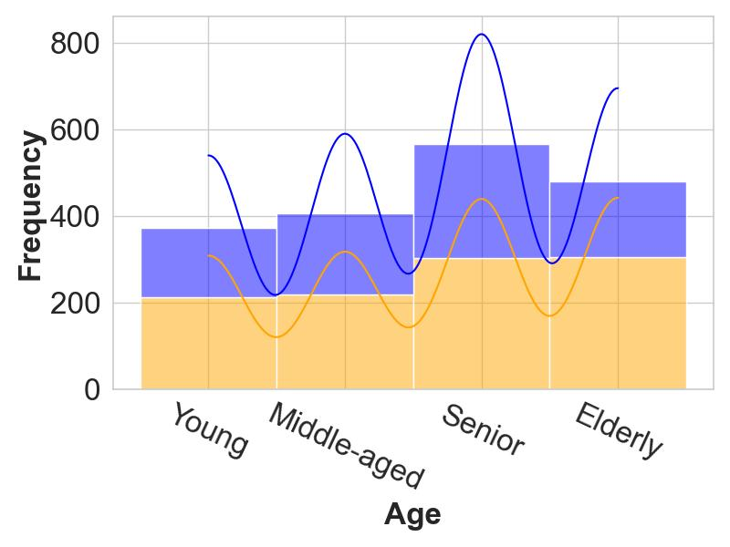 | 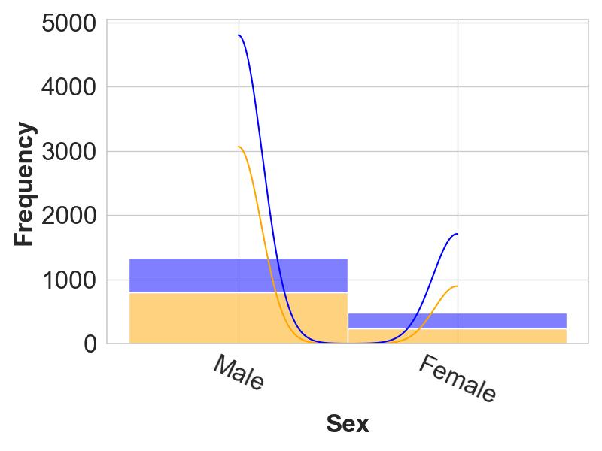 | 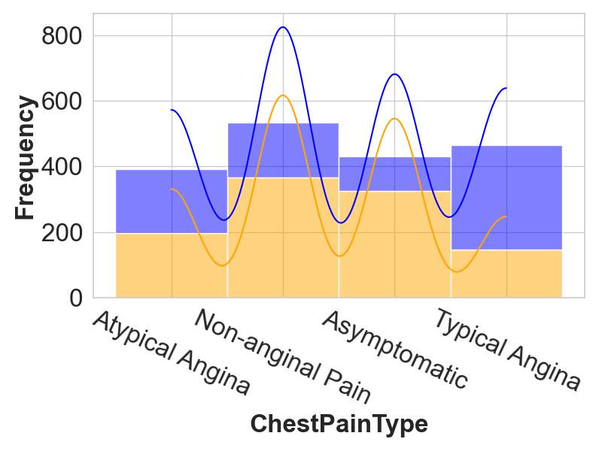 | 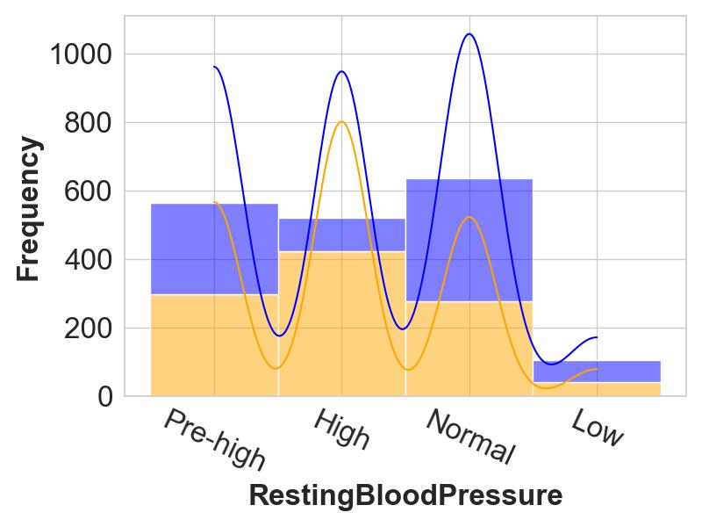
(a) | (b) | (c) | (d)
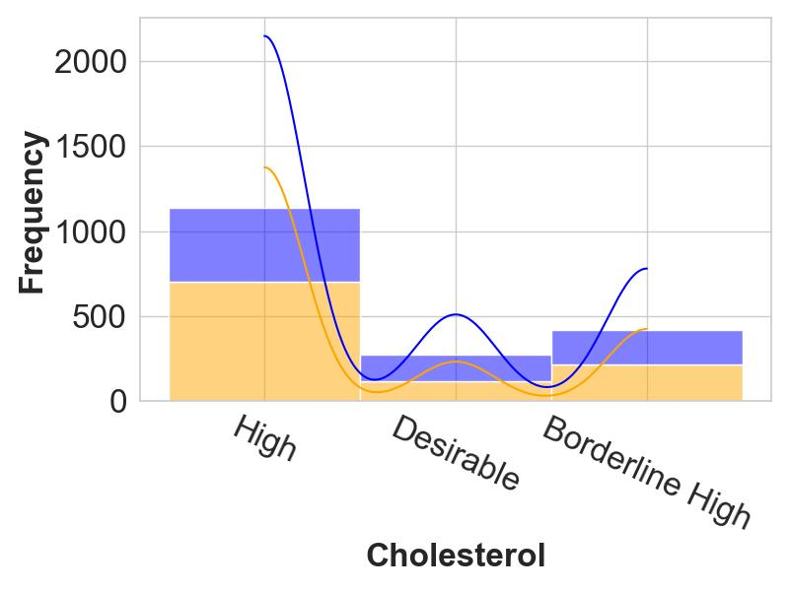 | 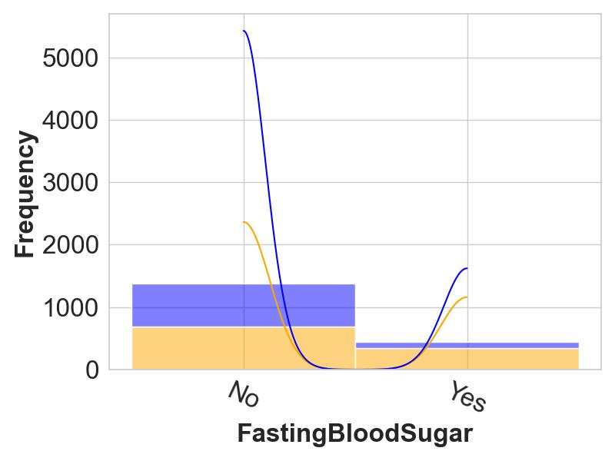 | 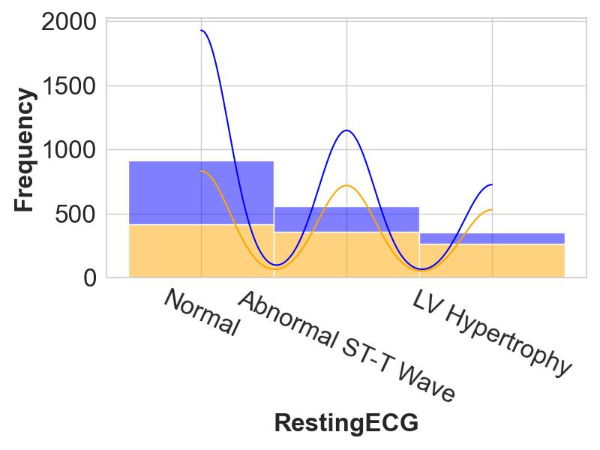 | 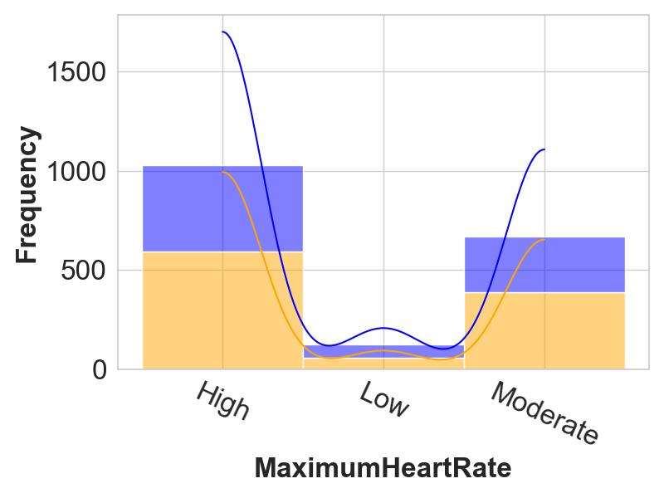
(e) | (f) | (g) | (h)
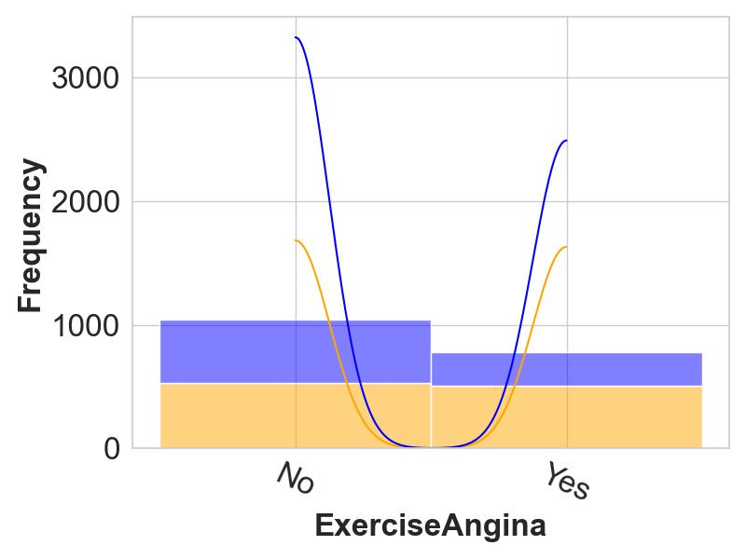 | 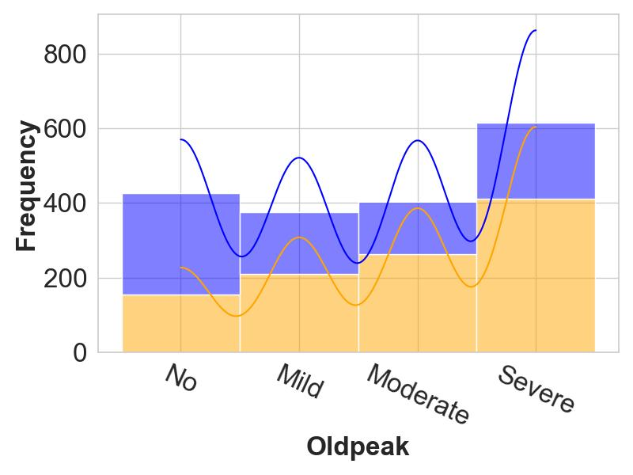 | 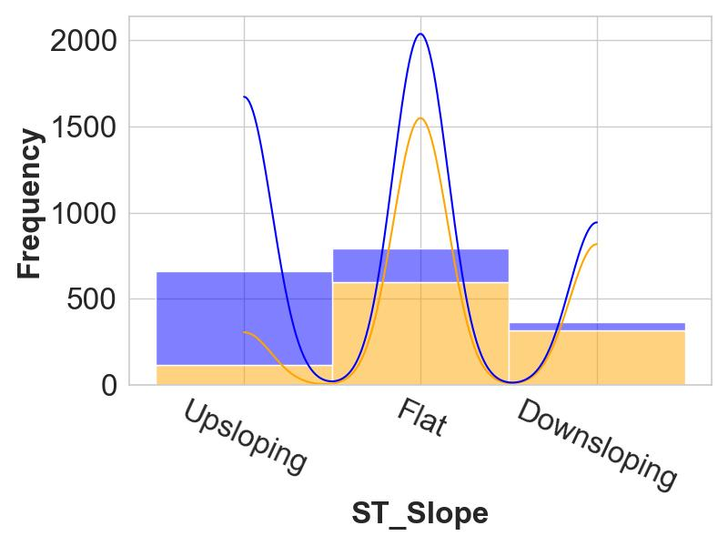 | 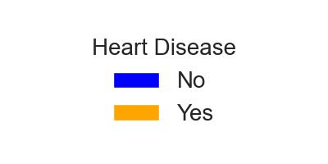
(i) | (j) | (k)
Fig. 2 Distribution of HD prediction features
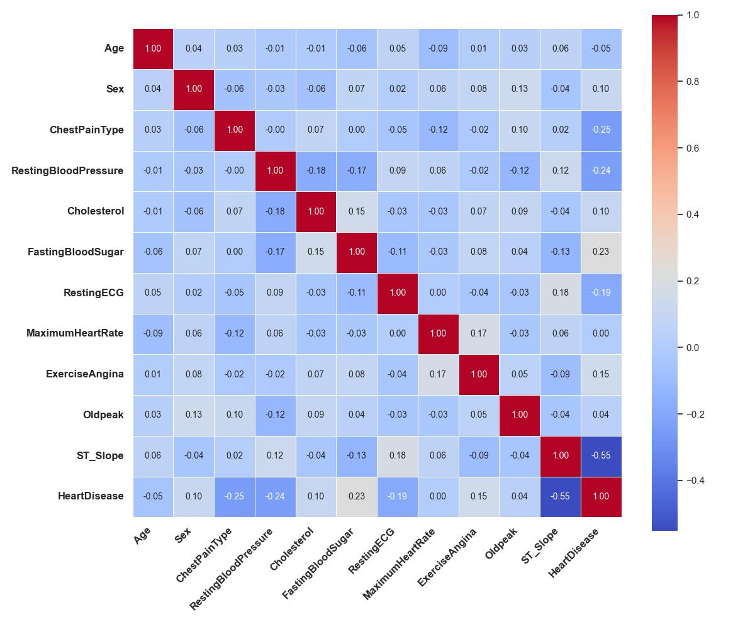
Fig. 3 Correlation heatmap of features for HD prediction

4.4.2 Key Generation and Data Encryption

The objective of this stage is to encrypt the $Δ$ by generating a pair of public and private keys (κ and ρ) using the ElGamal cryptosystem, as described in Section 3.1. Here, CC generates (κ, ρ). However, to reduce the workload of CC, encryption responsibility is distributed among CC and the two CRs for parallel computation. CC keeps the λ and one Δ_{i} for itself while splitting the remaining dataset into two parts and distributing them randomly, along with the κ, between two CRs. CC and the two CRs secure their respective parts of the dataset by encrypting each provided Δ_{i} to its encrypted form Θ_{i}, where each value is represented as a ciphertext pair (c₁, c₂). For each Δ_{i}, CC and the CRs generate new ephemeral keys k_{i} during encryption. Since each feature has only a few discrete categories, the same category always produces the same ciphertext within that feature. This allows the ML models to correctly distinguish between category values during training. For λ, CC applies a simple binary encoding, converting 'Yes' to 1 and 'No' to 0, producing λ′. Once encryption is complete, each CR sends the encrypted features along with the corresponding k_{i} to the CC. The CC then combines all encrypted parts into a single dataset, $Θ=\{Θ_{1}, …, Θ_{d}, λ'\}$. The key generation and data encryption processes are executed using custom Python functions, as outlined in Algorithm 1.

4.4.3 Data Decryption and Verification

In this stage, CC operates the first verification by checking the consistency of datasets in Θ before sending it to the SP, since it is a serious issue of HD prediction, and inconsistency detection after model training would require repeating the entire process. Using the ρ, the CC decrypts Θ_{i} and compares the results with the original Δ_{i}, following Algorithm 1. Since decryption of all encrypted values is computationally expensive, verification is performed on randomly selected samples, where decrypted values are matched against the original records to detect inconsistencies. If no mismatches are found, the CC forwards Θ to the SP for model training.
Algorithm 1 Dataset Preparation, Protection and Verification
Input: Seven datasets ω₁, ω₂, …, ω₇
Output: Encrypted dataset Θ = {Θ₁, …, Θ₁₁, λ′}
Step 1: Data Collection and Preparation
1: Collection of ω = {ω₁, …, ω₇} by CC from various sources
2: Standardization of all ω_{k} into uniform format by CC
3: Combination of ω into unified $Δ=\sum_{k=1}^{7}{ω_{k}}$ with ξ₁,…,ξ₁₂
4: Conversion of selected Δᵢ ∈ {Δ₁, Δ₄, Δ₅, Δ₈, Δ₁₀} into categorized form by CC
Step 2: Key Generation and Data Encryption
1: Generation of (κ, ρ) using ElGamal by CC
2: Partition of Δ among CC, CR1 and CR2
3: Encryption of all Δ_{i} → Θ_{i} using κ and kᵢ by CC, CR1, CR2 and binary encoding of λ to λ′ by CC
4: Aggregation of Θ = {Θ₁, …, Θ₁₁, λ′} by CC
Step 3: Data Decryption and Verification
1: Decryption of selected Θᵢ using ρ by CC
2: Comparison of decrypted values with corresponding original Δᵢ for randomly selected samples
3: Forwarding of Θ to SP if verification is successful

4.4.4 Data Preprocessing and Model Training

Here, the SP standardizes the Θ using the StandardScaler technique, denoted as δ. Since each Θᵢ is represented as an encrypted ciphertext pair (c₁, c₂), where c₁ is a random masking component and c₂ carries the data information, a custom preprocessing step extracts c₂ from each pair before standardization. Standardization ensures all features have a mean of zero and a variance of one, transforming Θ_{ij}​ into θ_{ij}​ as below. It is needed to ensure all features contribute equally by removing scale differences.
$$θ_{ij} = \frac{Θ_{ij}-μ_{iC}}{σ_{iC}}$$ | (1)
where, Mean, $μ_{iC}= \frac{1}{r}\sum_{j=1}^{r}{Θ_{ij}}$ | (2)
and, Standard Deviation, $σ_{iC}= \sqrt{\frac{1}{r}\sum_{j=1}^{r}{ }{\left(Θ_{ij}-μ_{iC}\right)}^{2}}$ | (3)
Now, the SP partitions θ into training (θ_{train}) and testing (θ_{test}) subsets using Python with the Scikit-learn library, where an 80:20 train-test split is applied. SP then evaluates a selection of ML models, including RF (η₁), XGB (η₂), and LR (η₃). The models are implemented using Scikit-learn and XGBoost libraries. For each model, the SP computes performance metrics: Confusion Matrix (Π₁), Accuracy (Π₂), Precision (Π₃), Recall (Π₄), and F1-score (Π₅) using functions from Scikit-learn.metrics. Π₅ is used as the primary evaluation metric throughout the evaluation, as it balances both FP and FN, making it suitable for imbalanced datasets. In contrast, Π₂ alone could misrepresent performance in such cases, while metrics like Π₃ may not sufficiently capture the trade-off between Π₄ and false discovery rate. Algorithm 2 illustrates the procedure of this stage.

4.4.5 Ensemble Strategies and Final Model Selection

The objective of this stage is to determine the optimal configuration of models and the final model selection, following Algorithm 2. To identify the optimal configuration, SP follows a stage-wise grid search approach, tuning one hyperparameter at a time across several rounds. In this work, SP explores eight ensemble variants combining RF, XGB, and LR in various architectures to assess their performance. These include: StackingCV with RF as the meta-model and XGB, LR as base models (Eη₁), where base model predictions are combined through cross-validation and used as input features to train the RF meta-model; Ensemble of RF, XGB, and LR (η_{α}) with SVE (Eη₂), where predicted class probabilities from each model are averaged to produce the final output; η_{α} with HVE (Eη₃), where final predictions are determined by majority voting among the models; η_{α} with SVE and PCA (Eη₄), where PCA is first applied for dimensionality reduction before soft voting is performed; η_{α} with HVE and PCA (Eη₅), where PCA-transformed features are used with majority voting; η_{α} with SVE and IF (Eη₆), where IF is applied to remove outliers prior to soft voting-based ensemble learning; η_{α} with HVE and IF (Eη₇), where outlier-filtered data is used with hard voting for final prediction. For each configuration, SP applies an 80:20 train-test split to obtain θ_{train} and θ_{test}. The configuration that yields the best Π₅ is selected as the best performing model, η_{β}. η_{β}, along with its corresponding θ_{test}, Π₅, and δ, is then delivered to the CC for further validation.

4.4.6 Model Verification

Here, the CC validates the model η_{β} trained by the SP and proceeds to develop SYS as in Algorithm 2. For this, the CC takes θ_{test} provided by SP, applies η_{β} on it, and calculates Π₅, checking for an exact match. If matched, the CC then randomly selects θ_{test} from θ, applies η_{β}, and calculates Π₅, verifying whether it is greater than or equal to the reference Π₅ provided by the SP. If all checks pass, η_{β} is considered valid. The CC then proceeds to develop the SYS using η_{β}.
Algorithm 2 HD Prediction, and Verification
Input: Encrypted dataset Θ
Output: Validated model η_{β}
Step 1: Data Preprocessing and Model Training
1: Standardization of Θ → θ using δ
1: Partitioning of θ into (θ_{train}, θ_{test})
2: Training of models η₁, η₂, and η₃ by SP
3: Computation of metrics Π = {Π₁,…,Π₅}
Step 2: Ensemble Strategies and Final Model Selection
1: Stage-wise Grid search tuning over Eη₁, Eη₂, Eη₃, Eη₄, Eη₅, Eη₆, Eη₇, and Eη₈
2: Evaluation using θ_{train} : θ_{test} = 80:20
3: Selection of the best model η_{β} with the highest Π₅
4: Transmission of {η_{β}, θ_{test}, Π₅, δ} to CC
Step 3: Model Verification
1: Application of η_{β} on θ_{test} to compute Π₅ by CC
2: Validation if computed Π₅ = received Π₅ from SP
3: Random sampling of θ_{test} ⊂ θ
4: Verification if η_{β}(random θ_{test}) produces computed Π₅ ≥ received Π₅ from SP
5: Confirmation of η_{β} as valid

4.4.7 System Development and Secure Communication

Finally, CC develops a user-friendly interface, SYS, to allow secure interaction with SUs as in Algorithm 3. When an SU creates an account, SYS and SU both generate RSA key pairs, (κ_{SYS}​, ρ_{SYS}​) and (κ_{SU}​, ρ_{SU}​), respectively. Here, κ_{SYS}​ and κ_{SU} are shared with the SU and SYS, while ρ_{SYS}​ and ρ_{SU} remain securely stored on SYS’s and SU’s sides. These keys are generated and exchanged only once. Since this public key exchange step is the most vulnerable to man-in-the-middle (MITM) attacks, it is crucial that both κ_{SYS}​ and κ_{SU}​ are exchanged through a secure and trusted channel.
When submitting input queries d_{SU}​, the SU encrypts it using κ_{SYS}​, producing ed_{SU}​. The SU then generates a digital signature sign_{SU}​ over ed_{SU}​, signing them with ρ_{SU}​. This package including ed_{SU}​ and sign_{SU}​ is then sent to SYS. Upon receiving the package, SYS first verifies the sign_{SU} using κ_{SU}​. If valid, SYS decrypts ed_{SU} using ρ_{SYS}​ to get d_{SU}. Each feature value from d_{SU} is then categorized and encrypted using the corresponding k_{i}, previously generated by the CC and CRs. These encrypted values are then preprocessed using δ and passed into the η_{β}, which returns a prediction, d_{SYS}. d_{SYS} includes, i. a decoded label (e.g., "Yes" or "No"), ii. the percentage likelihoods for both outcomes, iii. a detailed contribution score from each input feature, indicating its impact on the decision. d_{SYS} is then encrypted again by SYS using κ_{SU}, producing ed_{SYS}. SYS signs ed_{SYS} with ρ_{SYS}, producing sign_{SYS} then sends the package to the SU. The SU verifies the sign_{SYS} using κ_{SYS}​, decrypts ed_{SYS} using ρ_{SU} to get d_{SYS}.
Algorithm 3 System Development and Secure Communication
Input: SU’s input query d_{SU}
Output: Encrypted prediction result ed_{SYS}
Step 1: Key Exchange
1: Generation of (κ_{SYS}, ρ_{SYS}) and κ_{SYS} shared with SU by SYS
2: Generation of (κ_{SU}, ρ_{SU}) and κ_{SU} shared with SYS by SU
Step 2: Secure Submission (SU → SYS)
1: ed_{SU} ← RSA encryption of d_{SU} using κ_{SYS}
2: sign_{SU} generation over ed_{SU} using ρ_{SU}
3: Transmission of {ed_{SU}, sign_{SU}} to SYS
Step 3: Prediction of HD (by SYS)
1: Verify sign_{SU} using κ_{SU}
2: Decryption of ed_{SU} → d_{SU} using ρ_{SYS}
3. Categorization and encryption of d_{SU} features using κ and k_{i}
4: Preprocessing with δ, prediction with η_{β} → d_{SYS}
Step 4: Secure Response (SYS → SU)
1: ed_{SYS} ← RSA encryption of d_{SYS} using κ_{SU}
2: sign_{SYS} generation over ed_{SYS} using ρ_{SYS}
3: Transmission of {ed_{SYS}, sign_{SYS}} to SU
Step 5: Result Access (by SU)
1: Verify sign_{SYS} using κ_{SYS}
2: Decryption of ed_{SYS} → d_{SYS} using ρ_{SU}

Experimental Analysis

Experimental Setup

All the procedures were conducted on a system running a 64-bit operating system with an Intel Core i5-8265U processor and 8 GB of RAM. Visual Studio Code and Jupyter Notebook (.ipynb) served as the primary development environments. The implementation was carried out in Python using Scikit-learn and XGBoost libraries for ML models, and Joblib for model saving and loading. The models were trained, tested, and evaluated within the same environment using standard Scikit-learn functions.

Experimental Results and Verifications

This section presents a detailed breakdown of the results. In Section 4.4.1, numerical data were categorized to facilitate encryption and analysis using Table 2. A sample of the dataset before and after this transformation, along with the encrypted values using the ElGamal cryptosystem, is shown in Table 3. As described in Section 4.4.3, datasets are decrypted by the CC when necessary, and it can be verified that the decrypted values match the categorized data. The same table also illustrates the data standardization performed by the SP, as explained in Section 4.4.4.
Table 3 Example of categorized, encrypted, decrypted, and standardized data
Initial Data | Entity | Numeric Data
 | CC | Δ₁, Δ₂, …, Δ₁₁, λ = 49, Female, Non-anginal Pain, 160.0, 180.0, No, Normal, 156.0, No, 1.0, Flat, Yes
Data Categorization | Entity | Categorized Data
 | CC | Δ₁, Δ₂, …, Δ₁₁, λ = Middle-aged, Female, Non-anginal Pain, High, Desirable, No, Normal, High, No, Mild, Flat, Yes
Data Encryption | Entities | Encrypted Data
 | CR1 | Θ₁, Θ₂, …, Θ₅ = "(72709…93674, 29378…26979)", …,"(496487…37949, 93491…08580)"
 | CR2 | Θ ₆, Θ₇, …, Θ₁₀ = "(23262…03607,46506…04684)", …, "(22453…12219,92720…33085)"
 | CC | Θ₁₁, λ’ = "(10235…35138,39327…47652)",1
Data Decryption | Entity | Decrypted Data
 | CC | Δ₁, Δ₂, …, Δ₁₁, λ = Middle-aged, Female, Non-anginal Pain, High, Desirable, No, Normal, High, No, Mild, Flat, Yes
Data Standardization | Entity | Standardized Data
 | SP | θ₁, θ₂, …, θ₁₁, λ’ = -0.16340455768221038, …, -0.03128258654441089,1
The dataset was used to train three ML models: LR, XGB, and RF. Using an 80:20 train-test split and F1-score as the primary evaluation metric, RF achieved the highest score of 92.85%, followed by XGB (91.07%) and LR (85.97%).
To enhance performance, seven ensemble configurations were evaluated: StackingCV (92.27%), SVE (93.45%), HVE (92.20%), PCA with SVE (89.47%), PCA with HVE (88.79%), IF with SVE (93.71%), and IF with HVE (93.65%). All models underwent hyperparameter tuning via stage-wise grid search, with the best configuration, RF, XGB, and LR with IF and SVE, selected for final use. Table 4 outlines the detailed hyperparameter settings used for each configuration.
Table 4 Performance comparison of classification models using an 80:20 train-test split with tuned hyperparameters on encrypted categorized data
Classifiers | Hyper-parameters |  |  |  | F1-score (in %)
RF | train_test_split  - test_size: 0.2 | RandomForestClassifier  - n_estimators: 97 |  |  | 92.86
XGB | train_test_split  - test_size: 0.2 |  |  |  | 91.07
LR | train_test_split  - test_size: 0.2 |  |  |  | 85.97
RF+XGB+LR+StackingCV | train_test_split  - test_size: 0.2 | RandomForestClassifier  - n_estimators: 25 | StackingClassifier  - estimators: [lr, xgb]  - final_estimator: rf  - cv: 5  - passthrough: True |  | 92.27
RF+XGB+LR+SVE | train_test_split  - test_size: 0.2 | RandomForestClassifier  - n_estimators: 13 | VotingClassifier  - voting: ‘soft’ |  | 93.45
RF+XGB+LR+HVE | train_test_split  - test_size: 0.2 | RandomForestClassifier  - n_estimators: 53 | VotingClassifier  - voting: ‘hard’ |  | 92.20
RF+XGB+LR+PCA+SVE | train_test_split  - test_size: 0.2 | RandomForestClassifier  - n_estimators: 5 | PCA  - n_components: 0.95 | VotingClassifier  - voting: ‘soft’ | 89.47
RF+XGB+LR+PCA+HVE | train_test_split  - test_size: 0.2 | RandomForestClassifier  - n_estimators: 24 | PCA  - n_components: 0.95 | VotingClassifier  - voting: ‘hard’ | 88.79
RF+XGB+LR+IF+SVE | train_test_split  - test_size: 0.2 | RandomForestClassifier  - n_estimators: 10 | IsolationForest:  - contamination: 0.05  - n_estimators: 100 | VotingClassifier  - voting: ‘soft’ | 93.71
RF+XGB+LR+IF+HVE | train_test_split  - test_size: 0.2 | RandomForestClassifier  - n_estimators: 13 | IsolationForest:  - contamination: 0.05  - n_estimators: 100 | VotingClassifier  - voting: ‘hard’ | 93.65
Fig. 4 illustrates the PFI for the final selected model. The importance scores represent the mean decrease in F1-score when each feature is permuted, indicating the relative impact of each feature on the model's predictive performance.
Fig. 5 illustrates the SHAP summary for the final selected model. The plot displays the contribution of each feature to the predicted output across the full evaluation dataset, revealing both the magnitude and direction of their effects. Red and blue indicate high and low feature values, respectively, showing how each feature influences the prediction toward or away from the Heart Disease = Yes class.
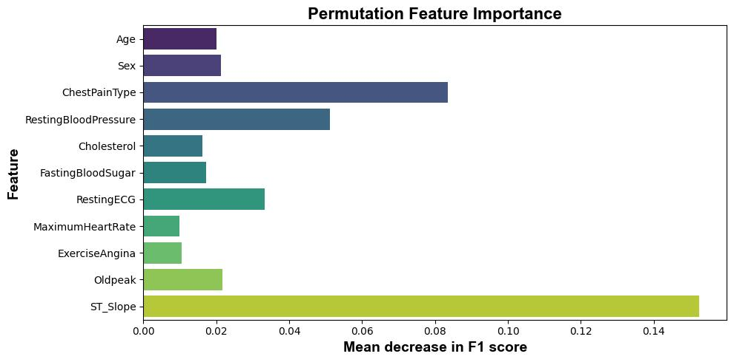
Fig. 4 PFI for final ensemble model (RF+XGB+LR+IF+SVE)

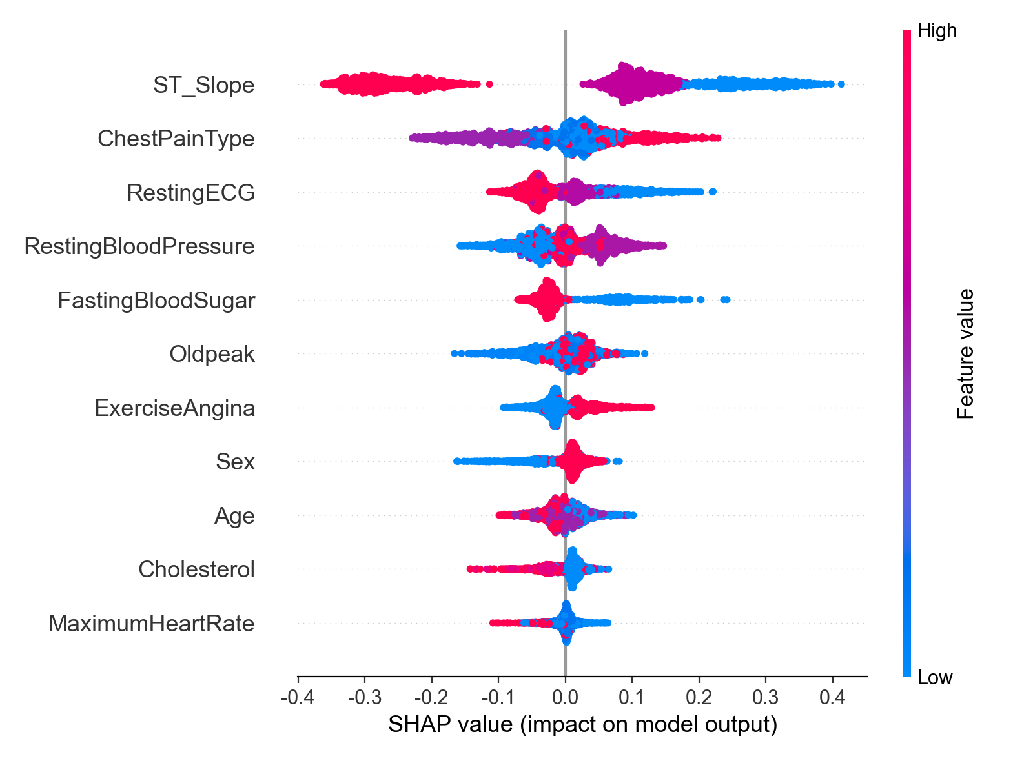
Fig. 5 SHAP summary for final ensemble model (RF+XGB+LR+IF+SVE)
Now. It is necessary to check the validation of assessing model accuracy, and Table 5 presents it. A True Model, trained on the complete dataset, consistently matches or exceeds the reference metrics across different test sets. In contrast, a False Model either randomly initialized or trained on a subset of the dataset, shows noticeably lower performance on randomly selected, unfamiliar test samples. This comparison helps determine whether the deployed model is genuine and valid. In Table 5, the 'Reference' column shows the F1-score reported by the SP, and the 'Calculated' column shows the F1-score computed by the CC using the same model received from the SP.
Table 5 Model validation via comparison between calculated and reference performance metrics
Model Type | Test Data Type | Accuracy (in %) |  | Precision (in %) |  | Recall (in %) |  | F1-score (in %)
 |  | Reference | Calculated | Reference | Calculated | Reference | Calculated | Reference | Calculated
True Model | Same Test Data | 92.05 | 92.05 | 92.31 | 92.31 | 95.15 | 95.15 | 93.71 | 93.71
 |  |  | 92.05 |  | 92.31 |  | 95.15 |  | 93.71
 |  |  | 92.05 |  | 92.31 |  | 95.15 |  | 93.71
 | Randomly Selected Test Data | 92.05 | 96.83 | 92.31 | 96.41 | 95.15 | 98.06 | 93.71 | 97.23
 |  |  | 96.71 |  | 96.23 |  | 98.08 |  | 97.14
 |  |  | 96.71 |  | 96.22 |  | 98.07 |  | 97.14
False Model | Same Test Data | 98.63 | 98.63 | 98.68 | 98.68 | 99.12 | 99.12 | 98.90 | 98.90
 |  |  | 98.63 |  | 98.68 |  | 99.12 |  | 98.90
 |  |  | 98.63 |  | 98.68 |  | 99.12 |  | 98.90
 | Randomly Selected Test Data | 98.63 | 84.82 | 98.68 | 84.68 | 99.12 | 89.33 | 98.90 | 86.94
 |  |  | 84.88 |  | 84.70 |  | 89.60 |  | 87.08
 |  |  | 84.63 |  | 84.33 |  | 89.58 |  | 86.88
Finally, as described in Section 4.4.7, Table 6 outlines the complete data flow for a single user interaction. It begins with the user’s query input, numerically encoded (e.g., 0 for the first category, 1 for the second category of the same feature, and so on. This encoding is applied to every categorical column in the dataset) to reduce data size. This encoded data is then encrypted using RSA encryption. A SHA-256 hash is computed on the encrypted data, and the digital signature is generated over this hash to ensure authenticity. The table further presents the system’s decrypted input, the predicted output, the RSA-encrypted prediction, the system-generated digital signature, and finally, the user’s correctly decrypted prediction.
Table 6 End-to-end data flow of SYS and a single user interaction
User Data | User’s RSA Encrypted Data, Digital Signature | System’s Decrypted and Decoded User Data | System’s Predicted User Output | System’s RSA Encrypted Output, Digital Signature | User’s Decrypted and Decoded Output
3, 1, 3, 2, 1, 0, 0, 1, 0, 0, 1 | eGWhGtwtlv8v9Ih... | Elderly, Male, Asymptomatic, Pre-high, Borderline High, No, Normal, Moderate, No, No, Flat | 1  22.68, 77.32  ξ11 <= -0.03, 0.4  -0.27 < ξ7 <= 0.85, -0.14  ξ3 > 0.26, 0.11  ξ10 <= -0.72, -0.08  ξ9 <= -0.87, -0.04  -1.66 < ξ2 <= 0.60, 0.02  ξ5 > 0.97, -0.01  -0.16 < ξ1 <= -0.13, 0.01 | Xft5SA/Z6rUwlGq6i... | HeartDisease: Yes  Prob. of No: 22.68%  Prob. of Yes: 77.32%  Feature Condition, Contribution  ST_Slope <= -0.03, 0.404  -0.27 < RestingECG <= 0.85, -0.144  ChestPainType > 0.26, 0.107  Oldpeak <= -0.72, -0.08  ExerciseAngina <= -0.87, -0.038  -1.66 < Sex <= 0.60, 0.017  0.11 < RestingBloodPressure <= 1.23, 0.009  MaximumHeartRate <= -0.65, 0.007  Cholesterol > 0.97, -0.006  -0.16 < Age <= -0.13, 0.006
 | OxvxEE5Qwv7QuZz... |  |  | K/1v6idz2jRZh8jeu...
Here, Table 7 summarizes the sizes of various components exchanged between user and system during communication. The user sends an RSA encrypted user query (256 bytes), and a digital signature (256 bytes). Similarly, the system responds with its RSA encrypted output (512 bytes), and a digital signature (256 bytes).
Table 7 Component sizes in SU–SYS communication
Component | RSA public key | RSA private key | SU's data | SU's RSA-encrypted data | SYS's data | SYS's RSA-encrypted data | RSA signature
Type | bytes | bytes | str | str | str | str | str
Size (in bytes) | 1678 | 450 | 21 | 256 | 125 | 512 | 256
Fig. 6 presents the SHAP waterfall explanation generated for the specific prediction shown in Table 6 using the RF + XGB + LR + IF + SVE ensemble model. It quantifies the exact contribution of each feature to the final prediction probability (77.32%), where positive and negative SHAP values respectively increase or decrease the predicted likelihood of heart disease. The plot reveals how Chest Pain Type, ST Slope, and Cholesterol collectively drive the model’s decision toward a higher probability of heart disease for this user.
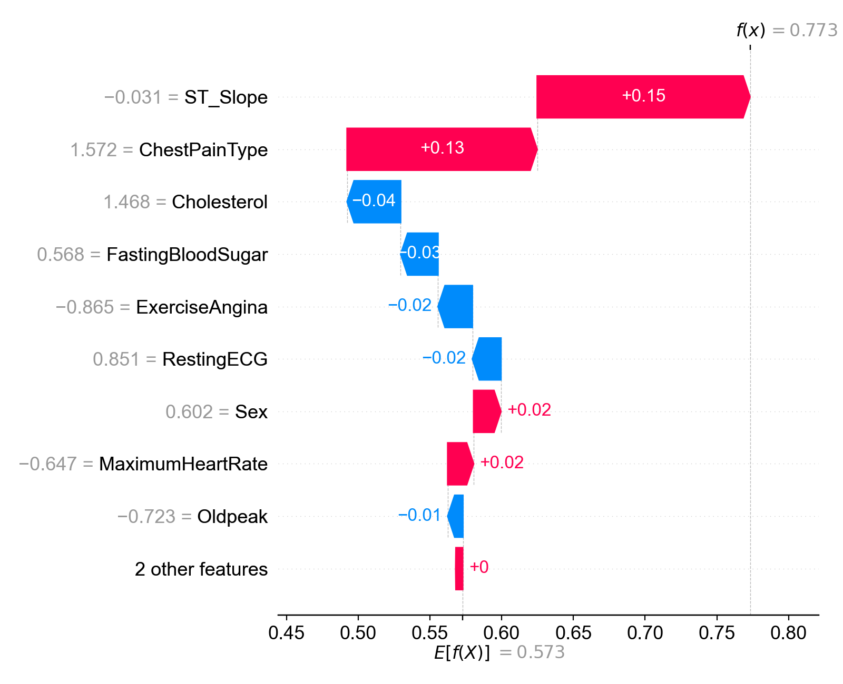
Fig. 6 SHAP waterfall explanation showing feature contributions for the specific user instance
Fig. 7 presents the LIME explanation for the same prediction shown in Table 6, corresponding to one user’s interaction.
It highlights the top features that influenced the model’s decision, positively or negatively, offering insight into why the system predicted a high probability (77.32%) of heart disease for the user using the RF + XGB + LR + IF + SVE ensemble model.
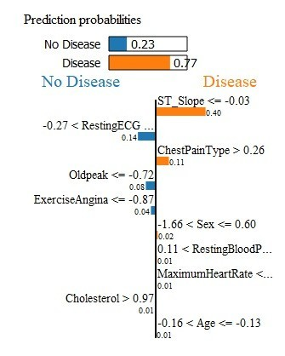 | 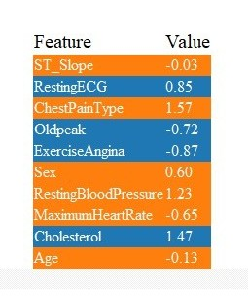
Fig. 7 LIME explanation showing top features influencing the user's prediction
Table 8 presents the time required for dataset security, model training and verification, and secure SU–SYS interactions in the proposed framework.
Table 8 Time requirements for dataset security, model training, and user–system interaction steps
Process Stages | Steps | Time Required  (in milliseconds)
Dataset Security and Verification | Dataset Preprocessing, Key Generation (private and public key sizes - 0.87 KB), Encryption Time (full dataset) and Decryption Time (full dataset) | 7500
Model Training, Optimization, Verification | RF | 223.87
 | XGB | 117.47
 | LR | 13.61
 | RF+XGB+LR+StackingCV | 872.69
 | RF+XGB+LR+SVE | 184.10
 | RF+XGB+LR+HVE | 250.25
 | RF+XGB+LR+PCA+SVE | 203.93
 | RF+XGB+LR+PCA+HVE | 296.13
 | RF+XGB+LR+IF+SVE | 244.72
 | RF+XGB+LR+IF+HVE | 260.11
 | Model Verification (Prediction on 20% Test Data) | 9.97
SU–SYS Interaction | RSA Key Generation | 1070.31
 | SU–SYS Interaction | 2702.06

Comparative Analysis

Table 9 presents a comparative analysis of classification performance across four different data handling approaches: the Uncategorized Dataset, the Encrypted Uncategorized Dataset, the Categorized Dataset, and the Encrypted Categorized Dataset. All models were trained using the RF+XGB+LR+IF+SVE configuration with consistent hyperparameter optimization via stage-wise grid search and an 8:2 train-test split.
Table 9 Classification performance comparison across different data handling approaches
Dataset Type | Accuracy (%) | Precision (%) | Recall (%) | F1-Score (%)
Uncategorized Dataset | 91.23 | 93.64 | 95.19 | 92.78
Encrypted Uncategorized Data | 87.95 | 89.45 | 96.50 | 90.83
Categorized Dataset | 92.33 | 93.83 | 97.03 | 93.86
Encrypted Categorized Dataset | 92.05 | 94.26 | 96.41 | 93.71
Here, the Uncategorized Dataset refers to the datasets that were first merged and then preprocessed by removing inconsistencies. The Categorized Dataset was prepared by converting the numerical data from the Uncategorized Dataset into categorized form based on defined value ranges. The Encrypted Uncategorized Dataset applies the encryption process directly on the raw, uncategorized values, while the Encrypted Categorized Dataset reflects the proposed method, where input features are categorized and then encrypted before training.
Despite the added cryptographic complexity, the Encrypted Categorized Dataset maintained competitive performance with an accuracy of 92.05% and an F1-score of 93.71%, only slightly lower than the Categorized Dataset (92.33% accuracy, 93.86% F1-score). The differences are minor: accuracy decreased by 0.28%, precision improved by 0.43%, recall decreased by 0.62%, and F1-score dropped by only 0.15%. These variations are all under 0.5%, indicating that the proposed encryption method preserves classification performance while ensuring data confidentiality.
Furthermore, a comparison between the Encrypted Categorized Dataset and the Encrypted Uncategorized Dataset reveals the advantage of applying categorization prior to encryption. The Encrypted Categorized Dataset outperforms the Encrypted Uncategorized Data by 4.10% in accuracy, 4.81% in precision, and 2.88% in F1-score, despite a slight decrease of 0.09% in recall. This illustrates that categorization not only improves interpretability but also stabilizes model performance under encryption, confirming its role in enhancing secure ML frameworks.

HD Prediction and Allied Requirements

Based on HD prediction, cryptographic and allied requirements, this section analyzes and compares the proposed framework with [6-8], [10], and [11] as follows. Also, Table 10 presents a detailed comparison of the proposed system with existing HD prediction methods and recent privacy-preserving ML techniques, highlighting key advancements in encrypted training, model validation, and secure communication. Though the application domains of [7] and [8] are different but their processing methods are almost similar to this framework, that’s why [7] and [8] are considered as the comparable ones.
Novelty of Approach: While [6] uses rule-based CART and [11] employs K-modes clustering with Huang’s method, neither integrates encryption. Works such as [7] and [8] leverage FHE and FL but remain limited to gradient protection or inference stages. In contrast, the proposed system enables ElGamal-based encrypted training and validation, coupled with secure, signed communication, offering a privacy and verifiability retaining framework for healthcare system.
Privacy-Preserving Techniques: Unlike prior systems relying solely on FHE [7] or combined homomorphic encryption and federated learning [8], the proposed framework adopts cryptographic approaches using ElGamal and RSA with digital signatures. This combination provides efficient encryption, data authenticity, non-repudiation, and secure user query and its corresponding output exchanges, enhancing both security and usability.
Entity Design: Compared to traditional client–server or FL models, the proposed framework introduces a role–based division with CC, CR, SP, SU and SYS.
Dataset Security and Consistency: Existing methods [6], [10], and [11] do not address dataset security explicitly. While [8] avoids sharing raw data by local training, it does not provide explicit verification of encrypted datasets. The proposed system ensures data privacy through encryption by CC and CRs, and critically, the CC validates dataset consistency before training, a vital feature for trustworthy real-world deployment.
Model Trained-on: Previous works like [7] train models on plaintext data and perform encrypted inference, and [8] trains on raw data with encrypted gradients shared. The proposed system trains directly on encrypted categorized data, maintaining privacy without compromising model quality.
Model Validation and Consistency: Unlike other systems lacking explicit validation, the proposed system incorporates consistency verification by the CC, ensuring that the trained model’s computed results meet a trusted reference matrix.
Performance vs. Privacy Trade-off: Although [10] reports up to 99.03% accuracy using XGB on raw data, it lacks security validation for real-world scenario. The proposed system delivers 92.05% accuracy alongside verified input/output consistency and encrypted interaction, suitable for real–world, privacy-critical deployments.
Secure SU–SYS Interactions: In the proposed system, secure exchange is explicitly established via RSA encryptions and RSA signatures, ensuring both confidentiality and authenticity of exchanged data.
Table 10 Comparative analysis of proposed system with existing methods
Features | [6] | [7] | [8] | [10] | [11] | Proposed System
Novelty of Approach | CART with rule extraction | Softmax with FHE to resist model extraction | PFMLP with HE + FL for encrypted gradient training | - | K-modes clustering with Huang start | Encrypted training with ElGamal, verification, authentication and secure communication with RSA cryptosystem and digital signature
Application Domain | Heart Disease Prediction | Image classification | Metal fatigue strength, Image classification | Heart Disease Prediction | Heart Disease Prediction | Heart Disease Prediction
Dataset Source | IEEE Dataport | CIFAR-10 dataset | MNIST and metal fatigue datasets | Dataset-I: Cleveland Dataset  Dataset-II: Cleveland, Hungary, Switzerland, and Long Beach V | Kaggle dataset | Combined Datasets made from 7 Datasets: Cleveland, Hungary, Switzerland, Long Beach V, Stalog (Heart), a multispecialty hospital, and two unspecified sources
Entities | - | 2 entities: Client and Server | 2 entities: Client and Server | - | - | 5 entities: CC, SP, CR, SU and SYS
Dataset Security | - | - | Data not shared to the Server, encrypted gradient is shared to the Server | - | - | Using ElGamal Cryptosystem by CC and CRs
Verification of Dataset’s Consistency | - | - | No need, since training is done locally by Client | - | - | By CC
Dataset Encryption by | - | - | Each Client own | - | - | 2 entities namely CC and CRs
Model Trained-on | Raw data | Pretrained on plaintext, inference on encrypted data | Raw data,  encrypted gradients sent | Raw data | Categorized data | Encrypted categorized data
ML Algorithms | CART | ResNet-20 CNN | PFMLP | LR, KNN, SVM, DT, RFC, XGB | DT, RF, MLP, XGB | RF, XGB, LR, StackingCV, SVE, HVE
Best Performing  Model, Result | CART,  Accuracy: 87.25%,  Recall: 84.51%,  Precision: 88.24% | ResNet-20 CNN,  Accuracy: 92.43%, ±2.65% | PFMLP, Accuracy: 92.52% | Dataset-I: KNN,  Accuracy: 87.91%,  Precision: 88%,  Recall: 88%,  F1-Score: 88%  Dataset-II: XGB,  Accuracy: 99.03%,  Precision: 99%,  Recall: 99%,  F1-Score: 99% | MLP,  Accuracy: 87.28%,  Precision: 88.70%,  Recall: 84.85%,  F1-score: 86.71% | RF+XGB+LR+IF+SVE,  Accuracy: 92.05%,  Precision: 94.26%,  Recall: 96.41%,  F1-score: 93.71%
Model Validation | - | Compared with original model (98.43% identical results) | Accuracy loss <1% between Encrypted vs. plaintext baseline | - | - | Performance difference <0.5% between Categorized dataset and Encrypted Categorized dataset
Verification of Model’s consistency | - | - | No need, as Training is done locally by Client | - | - | By CC after trained by SP, calculated matrix result >= reference matrix result
Privacy-Preserving Techniques Used | - | FHE (RNS-CKKS scheme) | Paillier Homomorphic Encryption, Federated Learning | - | - | ElGamal, RSA
Secure Communications | - | Client and Server both send encrypted data | - | - | - | SU and SYS both send RSA encrypted data and digital signatures, and both verifies signatures

Identified Threats and Implemented Countermeasures

In the proposed system, several potential security threats were identified, and corresponding measures were implemented to address these threats. This section outlines these to ensure dataset consistency and system security.
- Dataset Confidentiality Breach
Threat: A CR could tamper with the dataset during encryption, or the SP could potentially learn confidential information from the encrypted dataset during the model training process, compromising the data’s confidentiality and integrity.
Solution: To prevent any single CR from gaining full access to the dataset, the CC splits it into three parts and sends the two parts to CR1 and CR2 for encryption, as described in Section 4.4.2. The CC retains two columns including the label column for encryption. This setup ensures that even if both CRs were to collaborate, they would still not have complete access to the dataset. Finally, CC verifies the integrity of the encrypted dataset as in Section 4.4.3 to ensure the honesty of the CRs.
- Predictable Encrypted Data
Threat: When the same encryption key is applied to many different features, the identical values in various features may generate the same encrypted result. This could allow an attacker to recognize patterns between features.
Solution: Generation of new ephemeral keys for each feature ensures that no two features share the same encryption key, as described in Section 4.4.2. This means that even if two features have identical values, their encrypted representations will still differ, preventing any attacker from identifying correlations between them. As a result, each feature remains securely encrypted on its own, protecting its integrity even if one feature is compromised.
- Inconsistency in Model Training
Threat: The SP may bypass proper training and submit a randomly generated model to the CC. To make the model appear valid, the SP could test it on a small portion of the data and send the metric results to the CC. Again, the SP could train the model on only a small portion of the dataset and then use the same portion for testing. This would create an unrealistically high performance score, since the model is being tested on data it already knows.
Solution: As outlined in Section 4.4.6, the CC validates the model by running it on the same test dataset used by the SP and comparing the outcomes with the F1-score provided by the SP. Again, as in Table 5, the CC selects test samples randomly from the full dataset and checks whether the model performs at least as well as the f1-score provided by the SP. Because the samples are chosen at random, many of them will be new to the model if it was not trained on the full dataset, making it difficult for the model to achieve similar or higher performance through over-fitting.
- Data Exposure Risk
Threat: When the SU submits queries and receives the result from the SYS, an attacker may intercept the communication and try to uncover the original data or prediction result. If the system allowed the SU to directly encrypt queries using ElGamal cryptosystem, the SYS would have to share both its public key and the ephemeral keys used for encryption. If the SU were malicious or shared the ephemeral key with an attacker, and the attacker obtained encrypted data, either from other SUs or from the medical datasets used for training, the original values could be recovered.
Solution: For SU, as outlined in Section 4.4.7, all data exchanged between the SU and SYS is protected using RSA encryption. The SU encrypts their queries with the SYS's public key. The SYS follows the same process when sending back results. This ensures that even if someone intercepts the message, they cannot access the original content, keeping the data secure from SU end to SYS end.
- Data Tampering and Forgery
Threat: There’s a risk that an attacker could alter the data or results in transit, injecting false inputs or tampering with predicted outputs, leading to incorrect predictions or loss of trust in the system.
Solution: To prevent tampering and ensure authenticity, both the SU and SYS sign their respective contents using their private keys, as detailed in Section 4.4.7. Each package includes the encrypted content and a digital signature that can be verified by the recipient using the sender’s public key. This guarantees that the data hasn’t been modified.

Conclusion

The proposed framework presents a privacy-aware and verifiable approach for HD prediction using patients’ encrypted medical data. By distributing the features among entities with separate ephemeral keys to encrypt the feature values of the categorized datasets, the framework ensures confidentiality, resulting in a secure encrypted dataset. To train the prediction model, the framework employs multiple ensemble learning strategies including SVE, HVE, and StackingCV, with hybrid variants further enhanced by dimensionality reduction via PCA and anomaly detection using IF. Feature relevance is assessed post-training using PFI, improving model transparency and guiding feature selection. The verifiable mechanisms of the framework confirm dataset consistency and accurate HD prediction. The RSA cryptosystem and RSA digital signature in SU–SYS interactions ensure query authenticity and prediction integrity. For user-facing interpretability, LIME is employed to visually explain individual predictions, offering insight into the key features behind model decisions, while SHAP provides both global and local interpretability by quantifying feature contributions and validating the consistency of those explanations across the dataset. Experimental results demonstrate that the encrypted categorized dataset achieves an accuracy of 92.05% and an F1-score of 93.71%, maintaining only a 0.28% and 0.15% drop, respectively, from the unencrypted categorized data. The model also outperforms the encrypted uncategorized dataset by 4.10% in accuracy and 2.88% in F1-score. Thus, the framework ensures secure and accurate ML-based HD prediction by balancing data privacy with verifiability and threat resilience. Future work may focus on exploring lightweight encryption schemes to reduce runtime and improve adaptability in resource-constrained environments.

Statements and Declarations

Availability of Data and Material

The dataset used in this study is publicly available from the Kaggle repository, as cited in references [27-33].

Competing Interests

On behalf of all authors, the corresponding author states that there is no conflict of interest. The authors declare that they have no known competing financial interests or personal relationships that could have appeared to influence the work reported in this paper.

Funding

The authors declare that no funding was received for this work.

Authors' Contributions

- Israt Tasnim Esha: Conceptualization, Data curation, Formal analysis, Investigation, Methodology, Project administration, Resources, Software, Validation, Visualization, Writing – original draft, Writing – review and editing.
- Dola Das: Conceptualization, Data curation, Formal analysis, Investigation, Methodology, Project administration, Resources, Supervision, Validation, Visualization, Writing – review and editing.
- Kazi Md. Rokibul Alam: Conceptualization, Supervision, Validation, Visualization, Writing – review and editing.

Ethics approval

This study used publicly available, de-identified datasets and did not involve human participants; ethics approval was not required.

Informed consent

Not applicable.

References

- Ponikowski P, Anker SD, AlHabib KF, Cowie MR, Force TL, Hu S, Jaarsma T, Krum H, Rastogi V, Rohde LE, Samal UC. Heart failure: preventing disease and death worldwide. ESC heart failure. 2014 Sep;1(1):4-25. doi: https://doi.org/10.1002/ehf2.12005
- Makhlouf A, Boudouane I, Saadia N, Ramdane Cherif A. Ambient assistance service for fall and heart problem detection. Journal of Ambient Intelligence and Humanized Computing. 2019 Apr 12;10:1527-46. doi: https://doi.org/10.1007/s12652-018-0724-4
- Heidenreich PA, Trogdon JG, Khavjou OA, Butler J, Dracup K, Ezekowitz MD, Finkelstein EA, Hong Y, Johnston SC, Khera A, Lloyd-Jones DM. Forecasting the future of cardiovascular disease in the United States: a policy statement from the American Heart Association. Circulation. 2011 Mar 1;123(8):933-44. doi: https://doi.org/10.1161/CIR.0b013e31820a55f5
- Al-Shayea QK. Artificial neural networks in medical diagnosis. International Journal of Computer Science Issues. 2011 Mar 1;8(2):150-4.
- Mohan S, Thirumalai C, Srivastava G. Effective heart disease prediction using hybrid machine learning techniques. IEEE access. 2019 Jun 19;7:81542-54. doi: https://doi.org/10.1109/ACCESS.2019.2923707
- Ozcan M, Peker S. A classification and regression tree algorithm for heart disease modeling and prediction. Healthcare Analytics. 2023 Nov 1;3:100130. doi: https://doi.org/10.1016/j.health.2022.100130
- Lee JW, Kang H, Lee Y, Choi W, Eom J, Deryabin M, Lee E, Lee J, Yoo D, Kim YS, No JS. Privacy-preserving machine learning with fully homomorphic encryption for deep neural network. iEEE Access. 2022 Mar 14;10:30039-54. doi: https://doi.org/10.1109/ACCESS.2022.3159694
- Fang H, Qian Q. Privacy preserving machine learning with homomorphic encryption and federated learning. Future Internet. 2021 Apr 8;13(4):94. doi: https://doi.org/10.3390/fi13040094
- Li JP, Haq AU, Din SU, Khan J, Khan A, Saboor A. Heart disease identification method using machine learning classification in e-healthcare. IEEE access. 2020 Jun 9;8:107562-82. doi: https://doi.org/10.1109/ACCESS.2020.3001149
- Ahamad GN, Shafiullah, Fatima H, Imdadullah, Zakariya SM, Abbas M, Alqahtani MS, Usman M. Influence of optimal hyperparameters on the performance of machine learning algorithms for predicting heart disease. Processes. 2023 Mar 1;11(3):734. doi: https://doi.org/10.3390/pr11030734
- Bhatt CM, Patel P, Ghetia T, Mazzeo PL. Effective heart disease prediction using machine learning techniques. Algorithms. 2023 Feb 6;16(2):88. doi: https://doi.org/10.3390/a16020088
- Chandrasekhar N, Peddakrishna S. Enhancing heart disease prediction accuracy through machine learning techniques and optimization. Processes. 2023 Apr 14;11(4):1210. doi: https://doi.org/10.3390/pr11041210
- Reddy KV, Elamvazuthi I, Aziz AA, Paramasivam S, Chua HN, Pranavanand S. Heart disease risk prediction using machine learning classifiers with attribute evaluators. Applied Sciences. 2021 Sep 9;11(18):8352. doi: https://doi.org/10.3390/app11188352
- Haraty RA, Otrok H, El-Kassar AN. A comparitive study of elgamal based cryptographic algorithms. InInternational Conference on Enterprise Information Systems 2004 Apr 14 (Vol. 4, pp. 79-84). SCITEPRESS.
- Mahajan P, Sachdeva A. A study of encryption algorithms AES, DES and RSA for security. Global journal of computer science and technology. 2013 Dec;13(15):15-22. doi: 10.5220/0002593600790084
- binti Suhaili S, Watanabe T. Design of high-throughput SHA-256 hash function based on FPGA. In2017 6th International Conference on Electrical Engineering and Informatics (ICEEI) 2017 Nov 25 (pp. 1-6). IEEE.
- Bellare M, Rogaway P. The exact security of digital signatures-How to sign with RSA and Rabin. InInternational conference on the theory and applications of cryptographic techniques 1996 May 12 (pp. 399-416). Berlin, Heidelberg: Springer Berlin Heidelberg.
- Pal M. Random forest classifier for remote sensing classification. International journal of remote sensing. 2005 Jan 1;26(1):217-22. doi: https://doi.org/10.1080/01431160412331269698
- Chen T, Guestrin C. Xgboost: A scalable tree boosting system. InProceedings of the 22nd acm sigkdd international conference on knowledge discovery and data mining 2016 Aug 13 (pp. 785-794). doi: http://dx.doi.org/10.1145/2939672.2939785
- LaValley MP. Logistic regression. Circulation. 2008 May 6;117(18):2395-9. doi: https://doi.org/10.1161/CIRCULATIONAHA.106.682658
- Sadhukhan B, Gupta P, Narayan A, Mourya AK, Kumar S. Empowering coronary heart disease diagnosis: a comprehensive analysis of machine learning models on clinical data with explainable AI insights. Multimedia Tools and Applications. 2025 Jun 27:1-30. doi: https://doi.org/10.1007/s11042-025-20974-0
- Wold S, Esbensen K, Geladi P. Principal component analysis. Chemometrics and intelligent laboratory systems. 1987 Aug 1;2(1-3):37-52. doi: https://doi.org/10.1016/0169-7439(87)80084-9
- Liu FT, Ting KM, Zhou ZH. Isolation forest. In2008 eighth ieee international conference on data mining 2008 Dec 15 (pp. 413-422). IEEE. doi: https://doi.org/10.1109/ICDM.2008.17
- Muraina I. Ideal dataset splitting ratios in machine learning algorithms: general concerns for data scientists and data analysts. In7th international Mardin Artuklu scientific research conference 2022 May 1 (pp. 496-504). doi: https://doi.org/10.1007/978-3-319-23528-8 1
- Kapila R, Ragunathan T, Saleti S, Lakshmi TJ, Ahmad MW. Heart disease prediction using novel quine McCluskey binary classifier (QMBC). IEEE Access. 2023 Jun 26;11:64324-47. doi: https://doi.org/10.1109/ACCESS.2023.3289584
- Altmann A, Toloşi L, Sander O, Lengauer T. Permutation importance: a corrected feature importance measure. Bioinformatics. 2010 May 15;26(10):1340-7. doi: https://doi.org/10.1093/bioinformatics/btq134
- [dataset] Abhishek AVS. Heart Disease Classification. Kaggle; 2023. [online] Available at: https://www.kaggle.com/datasets/abhishek14398/heart-disease-classification [Accessed: August 2024].
- [dataset] Fedesoriano. Heart Failure Prediction Dataset. Kaggle; 2021. [online] Available at: https://www.kaggle.com/datasets/fedesoriano/heart-failure-prediction [Accessed: August 2024].
- [dataset] Dumlao J. Cardiovascular_Disease_Dataset. Kaggle; 2024. [online] Available at: https://www.kaggle.com/datasets/jocelyndumlao/cardiovascular-disease-dataset [Accessed: August 2024].
- [dataset] Damarla R. Heart Disease Prediction. Kaggle; 2020. [online] Available at: https://www.kaggle.com/datasets/rishidamarla/heart-disease-prediction [Accessed: August 2024].
- [dataset] Sony R. UCI Heart Disease Data. Kaggle; 2020. [online] Available at: https://www.kaggle.com/datasets/redwankarimsony/heart-disease-data [Accessed: August 2024].
- [dataset] Ineubytes. Heart-Disease-Dataset. Kaggle; 2023. [online] Available at: https://www.kaggle.com/datasets/abhishek14398/heart-disease-classification [Accessed: August 2024].
- [dataset] Lapp D. Heart Disease Dataset. Kaggle; 2019. [online] Available at: https://www.kaggle.com/datasets/johnsmith88/heart-disease-dataset [Accessed: August 2024].

